2019年南中国海年会第三轮会议通知
时间：2019年10月23-25日
地点：中国·海南·三亚
一、会议简介
“2019年南中国海年会”将于2019年10月23-25日在中国海南三亚举行，本次会议由中国科学院深海科学与工程研究所和中国海洋学会共同主办。
南中国海年会系列会议已成功举办了5次，分别由厦门大学、广东海洋大学、香港中文大学、自然资源部第一海洋研究所和河海大学主办。本次会议是该系列会议的第6次会议，将围绕南海中尺度/次中尺度过程、深海环流、海洋环境变化等主题开展学术交流，会议提供口头报告和墙报两种展示形式。
二、会议主题
（1）南海中尺度/次中尺度过程现场观测
（2）南海海-气通量和上层海洋混合
（3）南海高频变化
（4）海洋间水交换和热/盐通量的多尺度变化
（5）南海深层环流
（6）南海中尺度过程和深层环流数值模拟
（7）南海环境海洋学
(8) 海洋学创新理论和方法
三、会议组织
主办单位：中国科学院深海科学与工程研究所
中国海洋学会
四、南海年会组委会
黄瑞新、郑全安、甘剑平、潘家祎、何宗儒、吴朝荣、曾若玄、管玉平、胡建宇、梁湘三、林明森、齐义泉、田纪伟、王东晓、王桂华、魏泽勋、谢玲玲、谢强、徐洪周
五、会议秘书处
宋 伟：wsong@idsse.ac.cn，0898-88380201，13824419782
刘素敏：liusumin@idsse.ac.cn，0898-88353871，13519805092
喻 琉：yuliu@idsse.ac.cn，0898-88380215，15521126855
2019年10月23日 14:00-20:00 会议注册，半山半岛帆船港酒店/三亚明申高尔夫度假酒店/鹿回头国宾馆酒店大堂
2019年10月24日- 25 日 学术报告，中科院深海科学与工程研究所综合楼10楼1003会议室
六、会议日程
七、会议有关事项
- 参会人员食宿自理。
- 会议收取注册费 1200 元，学生 600 元。
汇款方式： 收款单位名称：中国科学院深海科学与工程研究所
开户银行：上海浦东发展银行海口分行营业部
账 号：34010155260000685
社会统一信用代码：12100000400882946P
汇款用途请注明：2019 年南中国海年会注册费+姓名
- 缴纳时间：2019 年10月20日之前（特别提醒：请务必于此日期前完成费用缴纳，否则将无法及时开具有效报销凭证。）
- 海报事宜：
①海报尺寸不大于长1.2m×高0.9m，请与会专家和同学自行打印。如需在会议举办地打印，可选择中科院深海所协议打印店三亚新南宝打印店（协议价约76元，报深海所名）。新南宝打印店电话：13016273516，qq：354407029，距离会议地点约24分钟车程。
②请各位专家和同学在酒店大堂进行会议注册时将打印好的海报交于会议注册处统一粘贴。
- 请参会人员于10月9日前将参会回执(见附件)发邮件至scsworkshop2019@163.com,以便安排会议日程。
- 未尽事宜请联系会务组。
八、会议地点、酒店及交通
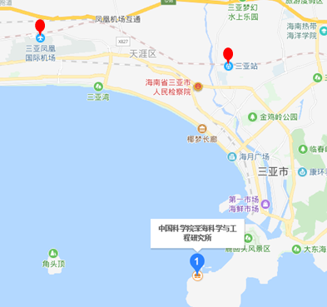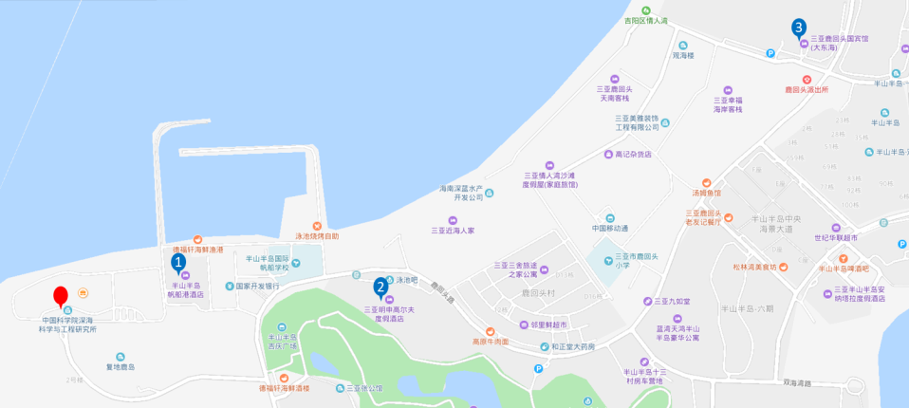
a会议地点位置图（蓝色标志） b宾馆位置图（1.帆船港、2.高尔夫、3.国宾馆）
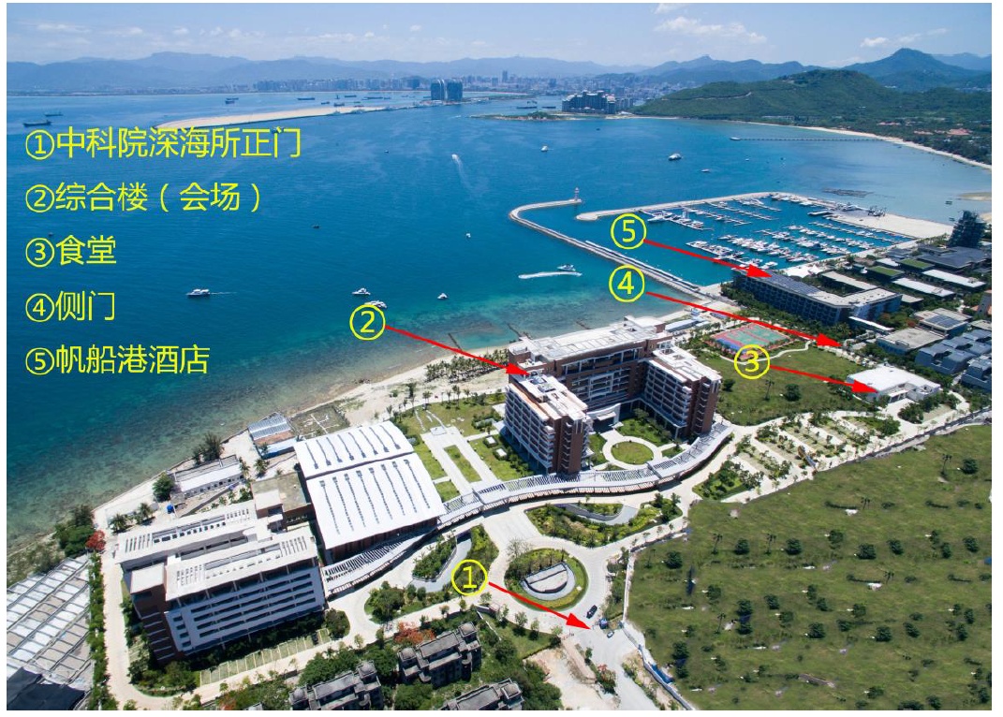
c 会场地图
会议地址：海南省三亚市吉阳区鹿回头路28号中科院深海科学与工程研究所
会议住宿：提供三个酒店供各位专家和同学自行选择，具体如下：
1．方案一：入住半山半岛帆船港酒店（约400元/间，含双早）
①交通路线一：三亚火车站---半山半岛帆船港酒店：
线路一：乘坐出租车，费用约50元；
线路二：步行280米，在火车站乘坐10路公交车，第二中学站下车，在第二中学站换乘3路/26路公交车，在深海研究所路口下车，继续步行482米到达酒店。
②交通路线二：凤凰机场---半山半岛帆船港酒店：
线路一：乘坐出租车，费用约80元；
线路二：步行157米，在凤凰机场站乘坐8路公交车，第二中学站下车，在第二中学站换乘3路/26路公交车，在深海研究所路口下车，继续步行482米到达酒店。
③交通路线三：半山半岛帆船港酒店---中科院深海科学与工程研究所
路线：酒店与会议地点有便利出入口，届时会开放门禁供各位专家出入，酒店距会议地点步行约5分钟。
2．方案二：入住三亚明申高尔夫度假酒店（约350元/间，含双早）
①交通路线一：三亚火车站---三亚明申高尔夫度假酒店：
线路一：乘坐出租车，费用约50元；
线路二：步行280米，在火车站乘坐10路公交车，第二中学站下车，在第二中学站换乘3路/26路公交车，在鹿回头村站下车，继续步行234米到达酒店。
②交通路线二：凤凰机场----三亚明申高尔夫度假酒店：
线路一：乘坐出租车，费用约80元；
线路二：步行157米，在凤凰机场站乘坐8路公交车，第二中学站下车，在第二中学站换乘3路/26路公交车，在鹿回头村站下车，继续步行234米到达酒店。
③交通路线三：三亚明申高尔夫度假酒店---中科院深海科学与工程研究所
路线：酒店安排班车往返于酒店和会议地点，车程约5分钟，具体另行通知。
3．方案三：入住鹿回头国宾馆（约480元/间，含单早）
①交通路线一：三亚站-鹿回头国宾馆：
线路一：乘坐出租车，费用约40元；
线路二：步行128米，在火车站乘坐35路/17路公交车，农垦医院站下车，在农垦医院站换乘3路公交车，在悦榕庄站下车，继续步行120米到达酒店。
②交通路线二：凤凰机场---鹿回头国宾馆：
线路一：乘坐出租车，费用约70元；
线路二：步行157米，在凤凰机场站乘坐8路公交车，第二中学站下车，在第二中学站换乘3路公交车，在悦榕庄站下车，继续步行120米到达酒店。
③交通路线三：鹿回头国宾馆---中科院深海科学与工程研究所
路线：酒店安排班车往返于酒店和会议地点，车程约10分钟，具体另行通知。

中国科学院深海科学与工程研究所
2019年9月29日

South China Sea Annual Meeting 2019
October 23-25, 2019
Sanya, China
(Third Announcement)
The “South China Sea Annual Meeting 2019” will be held from October 23 to 25, 2019 in Sanya, China, co-sponsored by the Institute of Deep-sea Science and Engineering (Chinese Academy of Sciences, CAS) and the Chinese Society for Oceanography.
The series of the workshops on “Mesoscale Processes in the South China Sea” has been successfully held for 5 times, sponsored by Xiamen University, Guangdong Ocean University, Chinese University of Hong Kong, First Institute of Oceanography (Ministry of Natural Resources), and Hohai University, respectively. This will be the 6th international workshop of the series, and will provide an opportunity for exchanging and sharing ideas and recent progresses on the mesoscale/submesoscale processes, deep circulation and environment conditions in the South China Sea. This workshop will have oral and poster presentation sessions.
Themes and topics
(1) In situ observation of mesoscale/submesoscale processes in the SCS
(2) Air-sea flux and upper layer ocean mixing in the SCS
(3) High frequency variability in the SCS
(4) Multi-scale variability of inter-ocean water exchange and heat/salt budget
(5) Deep water circulation in the SCS
(6) Numerical simulation of the mesoscale processes and deep circulation in the SCS
(7) Environmental oceanography of the SCS
(8) Innovative theories and methodology applied to the ocean
Sponsored by
Institute of Deep-sea Science and Engineering, CAS
Chinese Society for Oceanography
Conference Organizing Committee
Ruixin Huang, Quanan Zheng, Jianping Gan, Jiayi Pan, Chung-Ru Ho, Chau-Ron Wu, Ruo-Shan Tseng, Yuping Guang, Jianyu Hu, Xiangsan Liang, Mingsen Lin, Yiquan Qi, Jiwei Tian, Dongxiao Wang, Guihua Wang, Zexun Wei, Lingling Xie, Qiang Xie, Hongzhou Xu
Local Organizing Committee
Dr. Wei Song
E-mail: wsong@idsse.ac.cn
Telephone:0898-88380201
Ms. Sumin Liu
E-mail: liusumin@idsse.ac.cn
Telephone: 0898-88353871
Mr. Liu Yu
E-mail: yuliu@idsse.ac.cn
Telephone: 0898-88380215
October 23 , 2019 14:00-20:00 Conference registration, Sanya Serenity Marina Hotel/Mingshen Golf & Bay Resort Sanya/ Luhuitou State Guesthouse
October 24-25, 2019 Academic report, Room 1003, 10th floor, comprehensive building, Institute of deep-sea science and engineering, Chinese Academy of Sciences
Meeting Agenda
Meeting Related Issues
1. The participants will take care of their own accommodation.
2. Registration Fee ¥1200，student fee ¥600.
Method of remittance：
Name of payee：中国科学院深海科学与工程研究所
Bank of deposit: 上海浦东发展银行海口分行营业部
Account number：34010155260000685
Social uniform credit code: 12100000400882946P
Please specify the purpose of remittance：Registration Fee for South China Sea Annual Meeting 2019 +Name
3. Deadline for payment: October 20 ,2019 (special reminder: please pay the cost before the deadline, or it can’t be able to issue an invoice in time. )
4. Poster Issues:
①Each poster size is not more than 1.2 m- high by 0.9 m-wide, experts and students need to print by themselves. If you need to print in the meeting venue,you can choose the cooperation print shop with Institute of deep-sea science and engineering (about ¥76). Telephone of the printing shop Xin NanBao: 13016273516, qq: 354407029, about 24 minutes’ from the meeting Avenue by taxi.
② Experts and students can send the printed poster to the meeting registry when is registrating for the conference in the hotel lobby and Local Organizing Committee will poster up all together.
5. In order to arrange the meeting schedule, participants need to return the receipt (see attachment) by mail to scsworkshop2019@163.com by October 9, 2019.
6. The issues not mentioned can contact the Local Organizing Committee please.
Location, Hotel and Transportation
a. Meeting location (blue lable) b. Hotel location（1. Serenity Marina Hotel、2. Mingshen Golf、
3. Luhuitou State Guesthouse）
c. The map of campus
Meeting Address: #28 Luhuitou Road, Jiyang District, Sanya, China, Institute of Deep-sea Science and engineering, CAS
Hotel: Three hotels are provided for experts and students to choose,the details are as follows:
Option I. Sanya Serenity Marina Hotel (¥400 /night, with 2 breakfasts)
① Traffic Route 1: Sanya Railway Station - Sanya Serenity Marina Hotel:
Take a taxi: The fare is about ¥50.
By Bus: Walk about 280 meters long, take No. 10 bus at the Sanya railway station, transfer to No. 3/26 bus at the No. 2 middle school station, get off at the intersection of Institute of Deep-Sea Science and Engineering, and continue to walk 482 meters to the hotel.
② Traffic Route 2: Sanya Phoenix International Airport - Sanya Serenity Marina Hotel
Take a taxi: The fare is about ¥80.
By Bus: Walk 157 meters, take No. 8 bus at the Phoenix Airport station, transfer to No. 3/26 bus at the No. 2 middle school station, get off at the intersection of Institute of Deep-Sea Science and Engineering, and continue to walk 482 meters to the hotel.
Traffic Route 3: Sanya Serenity Marina Hotel- Institute of Deep-Sea Science and Engineering:
There are convenient entrances and exits between the hotel and the conference venue. The entrance guard will be opened for experts to enter and exit. The hotel is about 5 minutes’ walk from the conference venue.
Option II.Mingshen Golf & Bay Resort Sanya (¥350 /night, with 2 breakfasts)
①Traffic Route 1: Sanya Serenity Coast Marina Hotel - Mingshen Golf & Bay Resort Sanya
Take a taxi: The fare is about ¥50.
By Bus: Walk 280 meters, take No. 10 bus at the Sanya railway station, transfer to No. 3/26 bus at the No. 2 middle school station, get off at the Luhuitou Village station, and continue to walk 234 meters to the hotel.
②Traffic Route 2: Sanya Phoenix International Airport - Mingshen Golf & Bay Resort Sanya
Take a taxi: The fare is about ¥80.
By Bus: Walk 157 meters, take No. 8 bus at the Phoenix Airport station, transfer to No. 3/26 bus at the No. 2 middle school station, get off at the Luhuitou Village station, and continue to walk 234 meters to the hotel.
③Traffic Route 3: Mingshen Golf & Bay Resort Sanya- Institute of Deep-Sea Science and Engineering:
A courtesy shuttle bus will be operated between Mingshen Golf & Bay Resort Sanya and Institute of Deep-Sea Science and Engineering. The range of driving takes about 5 minutes. The details will be notified later.
Option III. Luhuitou State Guesthouse (¥480 /night, with 1 breakfast)
①Traffic Route 1: Sanya Serenity Coast Marina Hotel - Luhuitou State Guesthouse
Take a taxi: The fare is about ¥40.
By Bus: Walk 128 meters, take No. 35/17 bus at the Sanya railway station, transfer to No. 3 bus at the Agricultural Reclamation Hospital station, get off at the Yue Rongzhuang Station, and continue to walk 120 meters to the hotel.
②Traffic Route 2: Sanya Phoenix International Airport - Luhuitou State Guesthouse
Take a taxi: The fare is about ¥70.
By Bus: Walk 157meters, take No. 8 bus at the Sanya Phoenix International Airport, transfer to No. 3 bus at the No. 2 middle school station, get off at the Yue Rongzhuang Station, and continue to walk 120 meters to the hotel.
③Traffic Route 3: Luhuitou State Guesthouse - Institute of Deep-Sea Science and Engineering
A courtesy shuttle bus will be operated between Luhuitou State Guesthouse and Institute of Deep-Sea Science and Engineering. The range of driving takes about 10 minutes. The details will be notified later.

Institute of Deep-sea Science and Engineering, CAS
September 29, 2019

